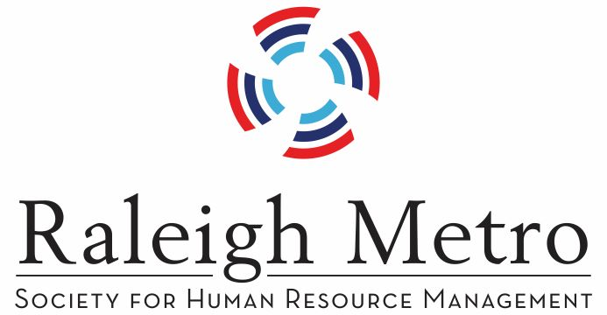
Employer Resource Workshop
Wednesday, July 24, 2019
8:00 am – 11:00 am
McKimmon Center – Raleigh, NC
Sponsored by: The Raleigh Mayor’s Committee for Persons with Disabilities
and the Raleigh Metro SHRM
Employee leave rights provided by the federal Family and Medical Leave Act of 1993 (“FMLA”), the American with Disabilities Act (“ADA”) and other state leave requirements present unique challenges to employers. This presentation will examine the key provisions and interplay of these laws, particularly where overlapping coverage and differing legal requirements complicate the leave and return-to-work process in light of the various rights and obligations under multiple statutory schemes. Our speaker, Kimberly Lehman, is an attorney with Ogletree Deakins.
The second portion of the presentation will cover the resources available to employers from a recruiting aspect. Our speaker, Ashley Hayes Chassereau from Vocation Rehabilitation, will explain the job placement process as well as the support services provided when hiring people with disabilities.
Learning Outcomes:
Participants will leave with a much greater understanding of strategies to immediately implement in addressing medical leave, accomodations, and recruiting issues.
1) Develop policies that meet employee needs, employer requirements, as well as comply with the ADA.
2) Determine legal requirements when your employees request medical leave.
3) Recruitment sources of qualified individuals for employers.
No charge to employers!

Certified; 2.0 hrs for HRCI; 2.0 hrs for SHRM
Full breakfast begins at 8:00 am
Register by contacting Kristy Dixon
at 919-749-0355 or kjmdixon@gmail.com
OR going to www.rmshrm.org under programs.

Employer Resource Workshop
Wednesday, July 24, 2019
8:00 am – 11:00 am

