2010 FACES OF INDEPENDENCE, PRODUCTIVITY AND INCLUSION

post secondary Education
William: He graduated from UNC Greensboro, with support from Beyond Academics. His UNC Greensboro certificate is in Integrative Community Studies. “I want the best for my nephew. I want him to have an education so he can have a career and achieve a sense of taking care of himself and making his own decisions.” — William’s Aunt Merlene.
Federal Legislation: The Americans with Disabilities Act (ADA) of 1990 enables society to benefit from the skills and talents of individuals with disabilities, allowing us all to gain from the increased purchasing power and abilities of these citizens. For people with disabilities, barriers to employment, transportation, public accommodations, public services, and telecommunications have had staggering economic and social costs for American society. The ADA aims to break down these barriers.

Key Term: Self-determination — is based on the principles of freedom, authority, support and responsibility. It means things like setting and pursuing goals, living in a place of one’s choosing, holding a job and taking responsibility for making a contribution back to the community. Self-determination can include exercising control over the state and federal funds made available for services and supports (“self-direction”).

NCCDD’s Vision: North Carolina should increase access to the services and supports that assist people in making key transitions by: increasing economic opportunities for competitive employment; ensuring that funds are spent in ways that support people’s goals; achieving accountability, advocacy, and outreach; supporting self-advocates and their families to achieve the individual’s life goals; and increasing post-secondary education options.

education
The Wilsons: “We advocated for our daughter to be educated in our local school district and not at a special school 100 miles away from home.”
After six months of advocacy, their daughter began attending the school in her area.

Federal Legislation: The Individuals with Disabilities Education Act (IDEA) ensures that children with disabilities not only have the right to attend public schools, but have access to the general curriculum and meaningful educational experiences. IDEA governs how states and public agencies provide early intervention, special education and related services to more than 6.5 million eligible infants, toddlers, children and youth with disabilities.

Key Term: Inclusion— the acceptance and encouragement of the presence and participation of individuals with developmental disabilities, by individuals without disabilities, in social, educational, work, and community activities, that enables individuals with developmental disabilities to: have friendships and relationships with individuals and families of their own choice; live in homes close to community resources, with regular contact with individuals without disabilities in their communities; enjoy full access to and active participation in the same community activities and types of employment as individuals without disabilities; and take full advantage of their integration into the same community resources as individuals without disabilities, living, learning, working, and enjoying life in regular contact with individuals without disabilities.

NCCDD’s Vision: North Carolina should improve service delivery systems by: supporting policies that improve integration, productivity, independence and inclusion; ensuring program accountability, advocacy, and outreach; assisting seniors to live in a family home, rented or owned; and improving information access.

Employment
Barton: “I’m pleased to be an active, independent and contributing member of the community, using my education and skills to earn a living.”
Barton has cerebral palsy. He is regularly employed as a consultant and writer.

Federal Legislation: The Rehabilitation Act of 1973 authorizes vocational rehabilitation services, supported employment, the Client Assistance Program, and independent living services. It also authorizes a variety of training and discretionary grants, administered by the Rehabilitation Services Administration.

Key Term: Supported Employment — services, such as long-term training and ongoing support, that enable individuals with developmental disabilities to engage in competitive employment in integrated workplaces.

NCCDD’s Vision: North Carolina should improve the knowledge, skills, and competencies of the workforce serving people with intellectual and other developmental disabilities by: introducing competency and values based training for direct support staff, supervisors and case managers; training other professionals to provide appropriate services; and improving leadership training.

Citizenship
Lisa: “I have an apartment of my own, I have a job at Arby’s. I vote and pay taxes.”

Lisa regularly receives commendations in her job and is a valued member of her community.

Federal Legislation: Rosa’s Law, signed by President Obama in 2010, changes references in federal law from the outdated and stigmatizing term, “mental retardation”(MR) to “intellectual disability.”

Key Terms: Self-advocacy — an individual speaking or acting for him or herself. Self-advocacy includes an individual determining what he or she wants, making his or her choice known and standing up for his or her rights as a person. Self-advocates also work together to achieve shared goals.

NCCDD’s Vision: Strengthen self-advocacy skills for those with intellectual and other developmental disabilities by increasing participation in leadership coalitions and training and by providing self-advocacy resources statewide.

NC Partners in Policymaking
A significant part of full citizenship is taking part in the public discussion of policy issues and making one’s views known. NC Partners in Policymaking, the longest continuously funded initiative of the NCCDD, has as its focus helping people with disabilities and their family members to develop their advocacy skills and ability to fully participate in the public dialogue.

Nc CoUNcIL oN dEvELoPmENTAL dISAbILITIES ANNUAL REPoRT FoR 2009-2010
Supporting self-determination, employment, and community inclusion for people with intellectual and developmental disabilities (I/DD) are primary aims of the North Carolina Council on Developmental Disabilities (NCCDD). Under authority granted in the Developmental Disabilities Assistance and Bill of Rights Act, PL 106-402, the Council funds a variety of initiatives directed at positive systems change in a variety of areas. These endeavors are undertaken by non-profit organizations, universities and government agencies. Among the initiatives are the following:


ASSURING QUALITY HEALTH CARE
Recognizing that some of the particular health
care needs of people with intellectual and other
developmental disabilities may go undiagnosed and untreated, the NCCDD has provided support for the Mountain Area Health Education Center (MAHEC) for its innovative work to improve medical education on developmental disabilities. Bruce Kelly, M.D., the MAHEC medical director led a meeting of physicians and other professionals to create the blueprint for the National Curriculum Initiative in Developmental Medicine, a pioneering effort in adult developmental medicine. The initiatives’s overall goal is to increase the capacity of medical professionals in order to serve people with developmental disabilities.
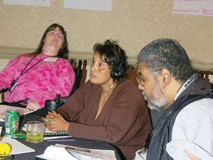
PROVIDING QUALITY SUPPORT SERVICES
Seeking to improve the quality of service delivered by direct support workers, the NCCDD has given a grant to the NC Providers Council for support of the College of Direct Support. This is a demonstration to further both professionalism and performance and to offer career support to Direct Support Professionals (DSPs). Through online coursework and study, DSPs learn about the laws and history of
the field, preferred service practices and the skills and knowledge that can help them be successful and advance. This competency-based program, intended to help develop a trained and stable work force of DSPs, also seeks to improve the status of these needed personnel and open up opportunities for advancement.
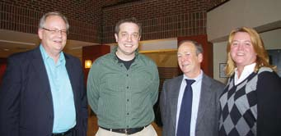
LEADERSHIP FOR THE FUTURE
To ensure sound leadership of organizations
serving the needs of people with intellectual and developmental disabilities, the NCCDD has funded the Advancing Strong Leadership in DD Initiative. After becoming aware that a majority of
those currently guiding these organizations would
be retiring in the next several years, the Council has supported this training to prepare promising middle managers to step up to leadership roles and to provide progressive services and supports to people with I/DD. The University of Delaware’s National Leadership Consortium on DD directs the Advancing Strong Leadership Initiative, tapping leading authorities from across the nation to meet and inform these developing leaders.
DEVELOPING ADVOCACY SKILLS
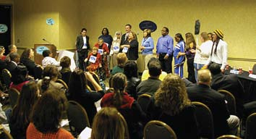
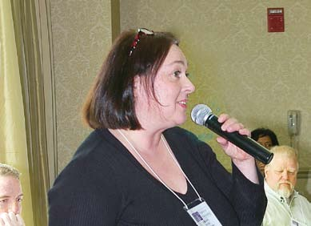
The North Carolina Partners in Policymaking program completed a successful year, with the graduation of a strong group of future advocates. People with intellectual or developmental disabilities and their family members participated in the program, which involved training and skills development training over eight weekend sessions. One goal of the program is to increase the ability of people with developmental disabilities and family members to participate more fully in their
communities and to make their voices heard. Those taking part learn how to express themselves and be involved in discussions
of public policy, particularly those affecting their own well-being. Activities include exercises in
communicating with public officials, legislators, the
media and other participants in the public dialogue. By improving self-advocacy skills, people are better enabled to guide and influence the future directions of their lives. The training is provided by leading experts in the field, including family members and self-advocates.

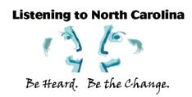
DEVELOPING NEW 5-YEAR PLAN
Under the federal law establishing Councils on Developmental Disabilities, the country’s 55 Councils
are required to develop plans every five years,
laying out their goals for the coming period and their strategies for achieving them. A critical element in plan development is to seek the views of people with I/DD, family members and the public. Opinion survey tools were developed in 2009-2010 for implementation in the following year, aimed at increasing the level of public input to be incorporated in plan development, with subsequent opportunities for public review and comment. The five-year plan
will be the primary guide for NCCDD’s activities in the period 2011 to 2016.

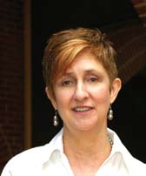

FROM THE NCCDD EXECUTIVE DIRECTOR
The North Carolina Council on Developmental Disabilities continues to work diligently to support positive, systems change initiatives, those endeavors that promise to enhance the quality of life for people with I/DD and their families and to create new opportunities for contribution to and inclusion in North Carolina’s communities. We seek to place North Carolinians with I/DD and their families at the center of systems change, advocacy and capacity building activities; to use feedback from all stakeholders and partners; and to be collaborative, transparent and results-oriented.
While there remains much to do to reach full community inclusion and self-determination for people with I/DD, we have come far. In this report, you meet four individuals and the federal legislation, terminology and vision that apply to their life circumstances. Each person and his or her family wants independence, productivity, self-determination and inclusion for their life--today and in the future.
The NCCDD rededicates itself to the mission of improving the lives of people with I/DD, promoting better, more cost-effective ways to offer self-advocates and their families the services and supports they need, and advancing communities in which all members are valued and included.
Holly Riddle, J.D, M.Ed Executive Director, NCCDD
THE COUNCIL*
CAROLINE “CARRIE” AMBROSE, RALEIGH – NCCDD VICE CHAIR, SELF-ADVOCATE
SADIE BREWINGTON BARBOUR, CLINTON – PARENT-ADVOCATE
JAMES BODFISH, PH.D. – CAROLINA INSTITUTE ON DEVELOPMENTAL DISABILITIES, UNC-CHAPEL HILL
SHERRY BRADSHER – NC DIVISION OF SOCIAL SERVICES, DHHS, EX-OFFICIO
ROBERT “RUSTY” BRADSTOCK, GREENSBORO – NCCDD VICE CHAIR, SELF-ADVOCATE
ADONIS BROWN, DURHAM – CHAIRMAN, NCCDD ADVOCACY AND LEADERSHIP COMMITTEE, SELF-ADVOCATE
LISA BYRD, DURHAM – SELF-ADVOCATE
LANIER CANSLER – SECRETARY, NC DEPARTMENT OF HEALTH AND HUMAN SERVICE
DAN COUGHLIN, CONCORD – NON-PROFIT REPRESENTATIVE
SENATOR KATIE DORSETT, GREENSBORO -REPRESENTATIVE OF THE NC SENATE
JONATHAN ELLIS, WILMINGTON – CHAIRMAN, NCCDD COMMUNITY CAPACITY BUILDING COMMITTEE, SELF-ADVOCATE
LOURDES M. FERNANDEZ, RALEIGH – PARENT-ADVOCATE
WILSON FINKS, CHAPEL HILL – SELF-ADVOCATE
CRYSTAL LEE FOREMAN, RALEIGH – SELF-ADVOCATE
LINDA HARRINGTON – NC DIVISION OF VOCATIONAL REHABILITATION, DHHS
REPRESENTATIVE VERLA C. INSKO, CHAPEL HILL – REPRESENTATIVE OF THE NC HOUSE OF REPRESENTATIVES
TARA LARSON – NC DIVISION OF MEDICAL ASSISTANCE, DHHS
MICHAEL MCNEILL, ABERDEEN – SELF-ADVOCATE
DESIREE PETERSON, RALEIGH – SELF-ADVOCATE
RANDY POWELL, ROCKY MOUNT – SELF-ADVOCATE
I. AZELL REEVES, GREENSBORO – PARENT-ADVOCATE
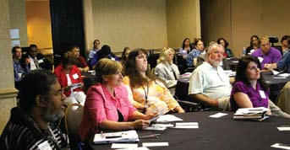
ROBERT J. “BOB” RICKELMAN, PH.D.,CHARLOTTE – NCCDD CHAIRMAN, PARENT-ADVOCATE
WALTER L. RUFF, III, SYLVA – PARENT-ADVOCATE
KEVIN RYAN, M.D. – NC DIVISION OF PUBLIC HEALTH, DHHS
PAUL SAGERMAN, M.D., WINSTONSALEM – PARENT-ADVOCATE
VICKI SMITH – DISABILITY RIGHTS NORTH CAROLINA
DENNIS STREETS – NC DIVISION OF AGING AND ADULT SERVICES, DHHS
DAVID I. TAYLOR, JR., STATESVILLE – SELF-ADVOCATE
AMANDA WAGONER, MCGRADY – PARENT-ADVOCATE
LEZA WAINWRIGHT-NC -DIVISION OF MENTAL HEALTH, DEVELOPMENTAL DISABILITIES, AND SUBSTANCE ABUSE SERVICES, DHHS
MARY WATSON – NC DEPARTMENT OF PUBLIC INSTRUCTION
MIKE WHITLEY, CHARLOTTE – CHAIRMAN, NCCDD DISABILITY SYSTEMS CHANGE COMMITTEE, PROVIDER REPRESENTATIVE
TRACY PARKER WILLETTS, WILMINGTON – NCCDD SECRETARY/TREASURER, PARENTADVOCATE
DEBRA WILSON, RICHLANDS, PARENT-ADVOCATE
LAURA YATES – NC DEPARTMENT OF CORRECTIONS, EX-OFFICIO
* AS OF OCTOBER 2010

